Democratic Republic of Congo Luba "Kifwebe" Mask —20th Century   
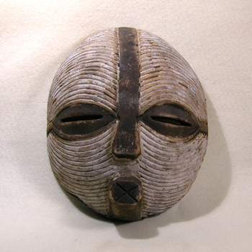  
Older Luba wooden mask. Round face with linear incisions and remains of white paint, squared mouth. Good age with minor losses around the edges. Of the several different mask types used by the Luba, this type of bowl-shaped mask with parallel grooves was worn with a raffia costume and danced in male/female couples representing spirits (kijwebe) which connect this world with the spirit world. Used to mark important periods of social transition and transformation. Nice example with desirable wear and showing signs of tribal use.   
  
9" tall   
  
SOLD